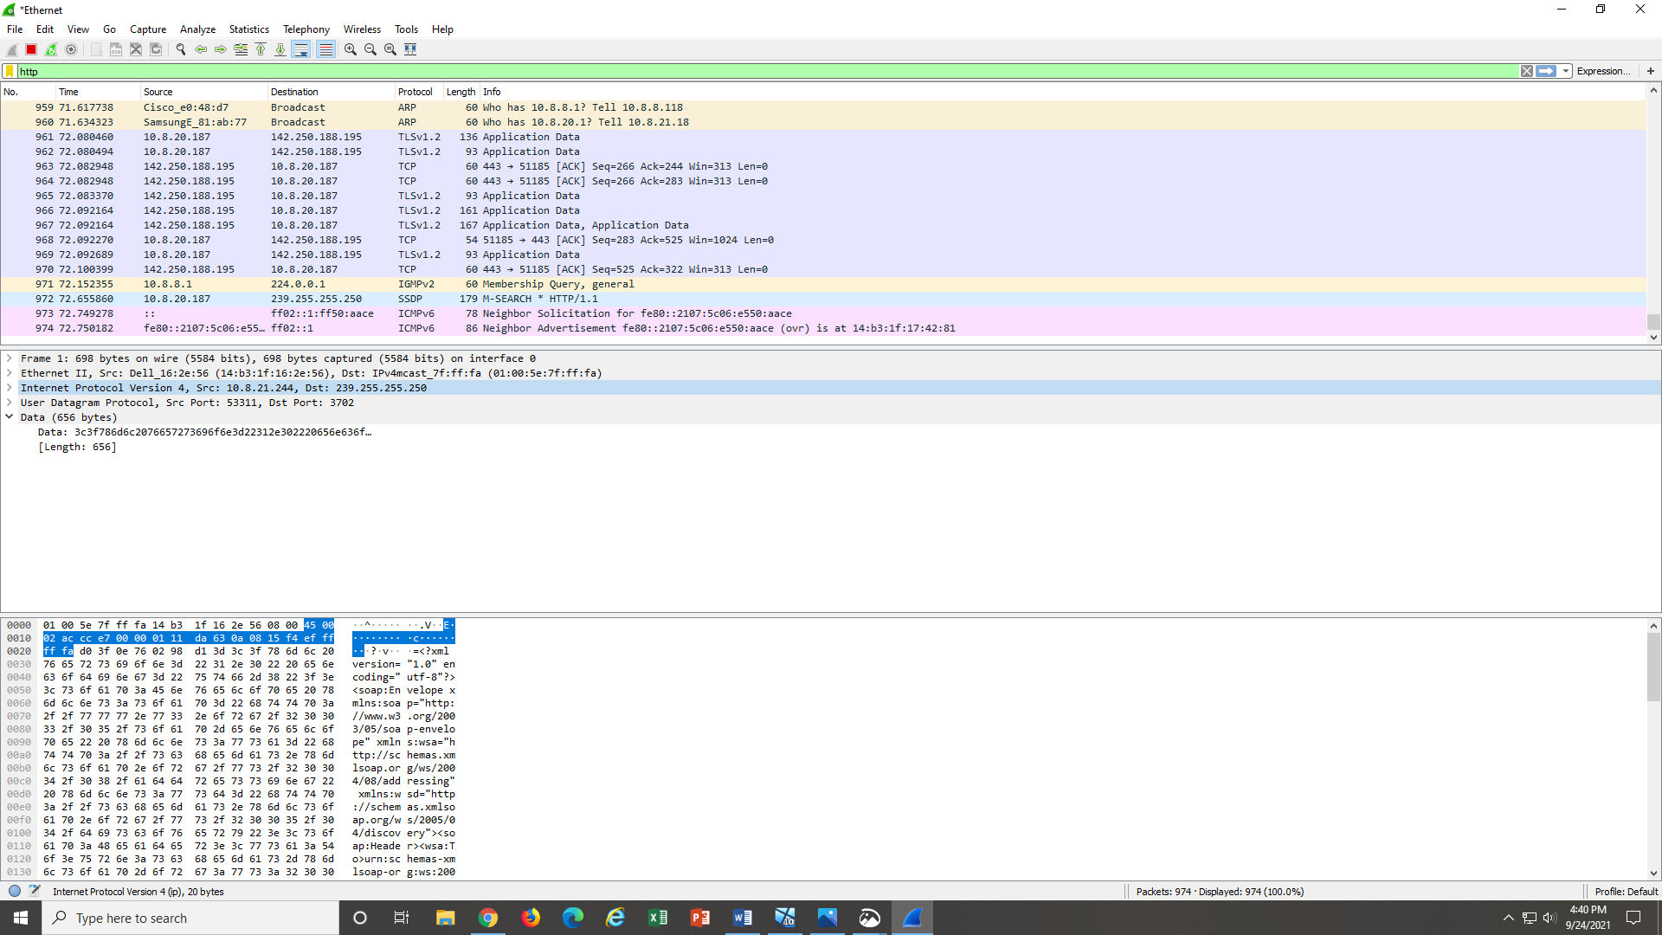

1. What is the internet address for your computer?

* 10.8.21.244

1. TCP,HTTP,ARP,ICMP

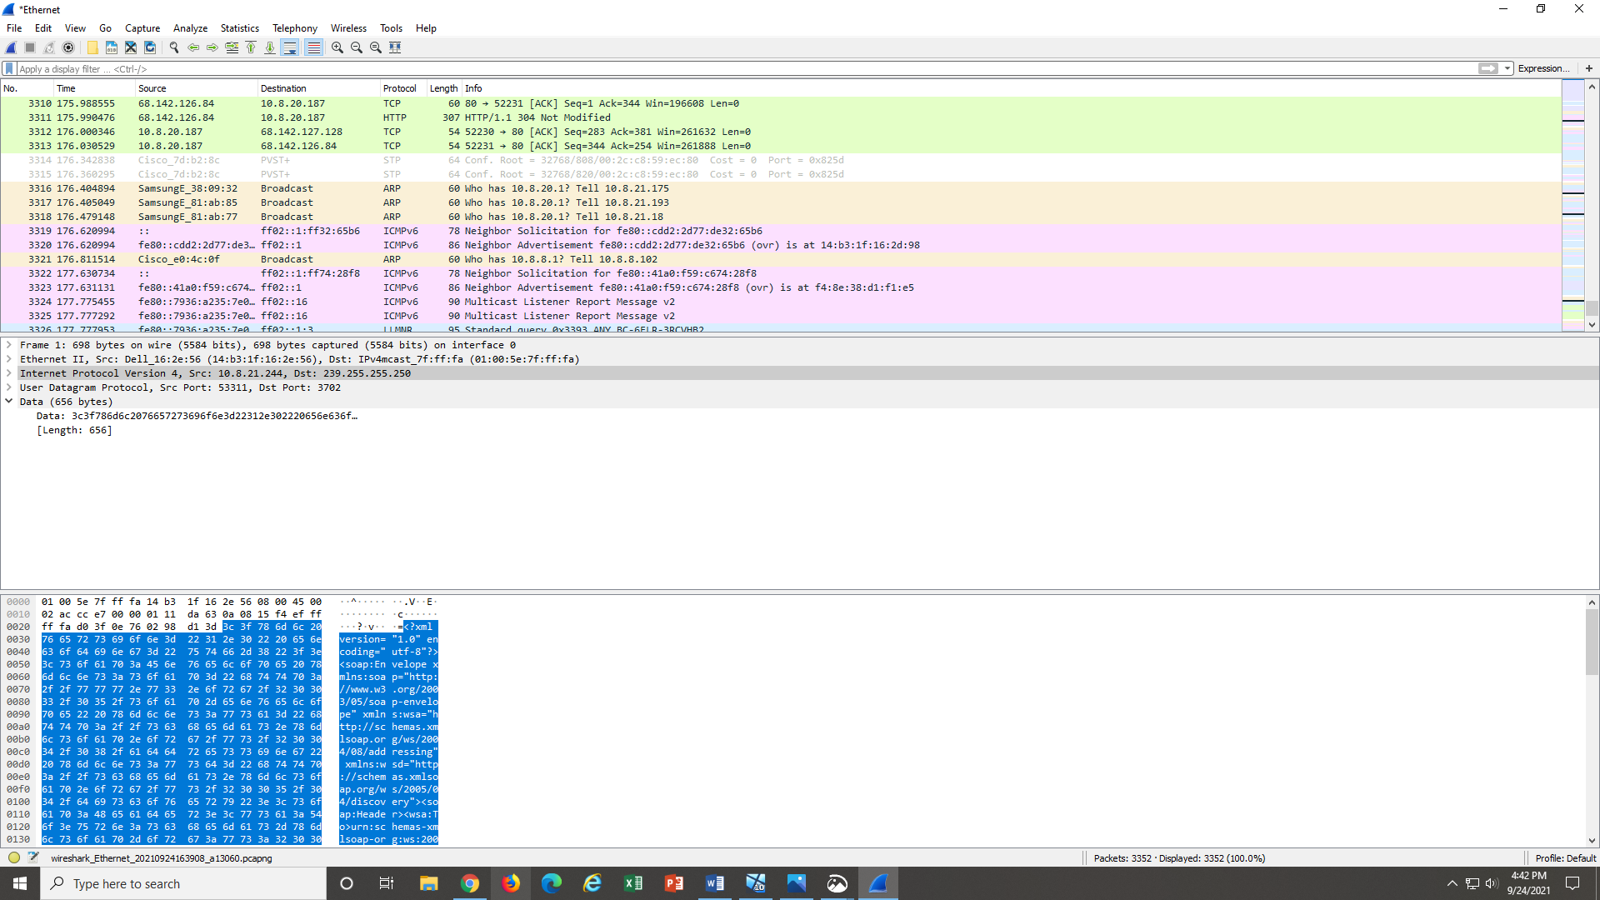

3.

* GET- Sept 24, 2021 16:42:04 .938720000
* OK- Sept 24, 2021 16:41:45 .138749000

Difference .938720000- .138749000= 0.799971

